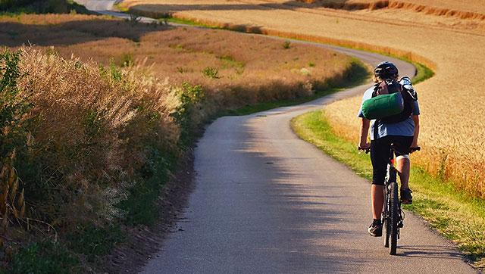

**Cycling Tour**

The Sahyadris, a part of the Western Ghats range includes the Konkan and the Kanara regions of Maharashtra, Goa and Karnataka. Spanning about 10 to 20 km in width and ranging from 900 to 1900 metres in elevation, the Sahyadri functions well in collecting a large portion of the rain bearing South Western monsoon clouds.

This unique feature makes this entire region (a UNESCO world heritage site) into a lush green paradise crisscrossed by rivers, forested reservoirs, waterfalls and most noticeably with a vibrant biodiversity. This particular ride takes the guests through plantations of Coffee, Tea and other aromatic spices, in the periphery of some of the richest wildlife sanctuaries while experiencing the warmth and hospitality of local families who host the guests in their home stays.

**Itinerary**

**Day 01: Bangalore - Mysore (Drive approx. 145 Km)**

Arrive in Bangalore and transfer to Mysore. Mysore, a city rich in culture and heritage is an excellent option to explore and visit. Visit to the Ambavilas Palace which was the seat of the Wadiyar dynasty who ruled the erstwhile Kingdom of Mysore.

**Overnight at the hotel in Mysore.**

**Meal Plan**: Breakfast

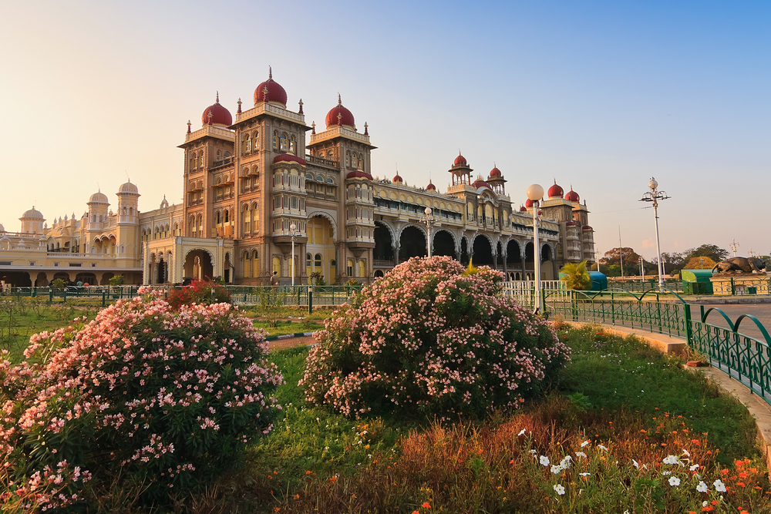

**Day 02: Mysore – Bylakuppe - Somwarpet**

**(Drive approx. 85 Km, Cycle approx. 40 Km)**

Start the day with an initial transfer to the township of Bylakuppe lying in the border of Coorg district.

**Bylakuppe** is one of the largest settlements of Tibetans in India; visit the Sera and the Namdroling monasteries. Post lunch, get down to the nitty gritty of getting the bikes fitted to specification and head out for a short familiarization ride. The destination for the day is a home stay tucked away from the hustle and bustle of the world.

**Overnight at the hotel in Somwarpet.**

**Meal Plan**: Breakfast, Lunch & Dinner

**Day 03: Somwarpet – Sakleshpur (Cycle approx. 65 Km)**

Journey continues towards the coffee growing hub of Sakleshpur. The road winds through evergreen forested tracts, coffee plantations and settlements. En-route visit the star shaped Manjarabad Fort, built in 1758 by Tipu Sultan as an outpost on the eastern slopes of the Western Ghats. Our overnight stop at a home stay in Sakleshpur.

**Overnight at the hotel in Sakleshpur.**

**Meal Plan**: Breakfast, Lunch & Dinner

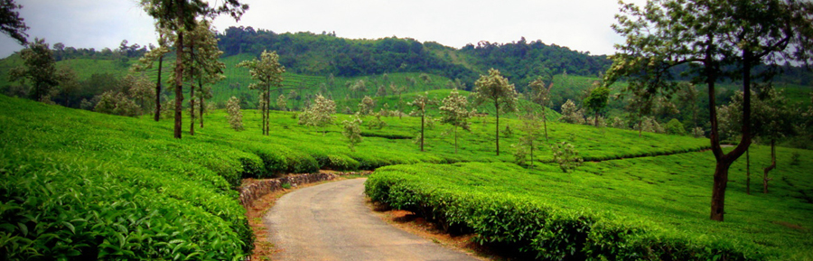

**Day 04: Sakleshpur – Balur (Cycle approx. 60 Km)**

Today is a relatively short day of cycling on the foothills of the eastern slope of the Ghats. Cycle deep in coffee country, riding through lush patches of greenery all around. Overnight stay in a comfortable coffee plantation bungalow.

**Overnight at the hotel in Balur.**

**Meal Plan**: Breakfast, Lunch & Dinner

**Day 05: Balur – Koppa (Cycle approx. 65 Km)**

The destination for the day is Koppa, a fairly hilly region of Coffee, Tea and Areca nut plantations. This beautiful part of the Western Ghats is set amidst giant reservoirs, rivers and wildlife sanctuaries. An idyllic 300 year old house will host the guests.

**Overnight at the hotel in Koppa.**

**Meal Plan**: Breakfast, Lunch & Dinner

**Day 06: Koppa – Madodi (Cycle approx. 80 Km)**

A fairly long day in relation to others, head towards the Sharavati valley and the Mookambika Wildlife Sanctuaries. The destination for the day is situated on the southern banks of the picturesque Linganamakki Reservoir.

**Overnight at the hotel in Madodi.**

**Meal Plan**: Breakfast, Lunch & Dinner

**Day 07: Madodi – Gundimane (Cycle approx. 80 Km)**

Cycle throughout the day along with the Sharavati Valley Wildlife Park and the Linganamakki Reservoir on the right. The destination for the day is at Gundimane lying in the far northern shores of the Reservoir.

**Overnight at the hotel in Gundimane.**

**Meal Plan**: Breakfast, Lunch & Dinner

**Day 08: Gundimane – Kudle Beach (Cycle approx. 100 Km)**

An exceptional day of cycling, first along the Talakalele and Linganamakki reservoirs and passing the Jog falls which is the second highest plunge Waterfall in India measuring at 253mts. After riding in the eastern slopes of the Ghats on the previous days, finally cross over the range and make the way towards the coast of the Arabian Sea. A Short stop at the 9th Century Kavaledurga fort and continue further on the last leg of the ride making the way to the Kudle beach on the outskirts of the township of Kumta.

**Overnight at the hotel in Kudle Beach.**

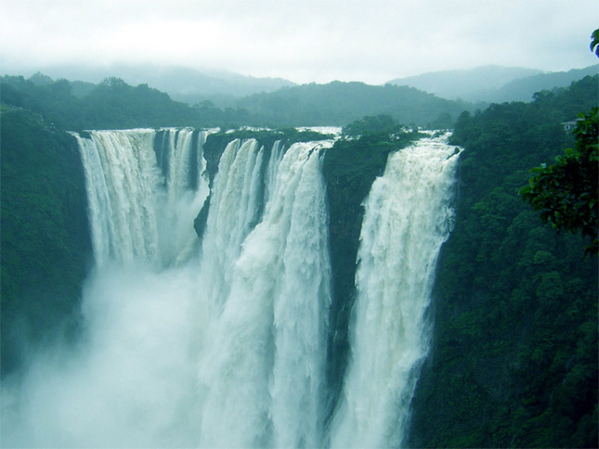**Meal Plan:** All Meals

**Day 09: Kudle Beach - Goa (Drive approx. 160 Km)**

A four hour long transfer takes the guests to the eternal getaway of India, Goa. Goa as a state is known for its beaches, colonial architecture and its places of worship. This is an ideal place for rest and recreation after the long ride.

**Overnight at the hotel in Goa.**

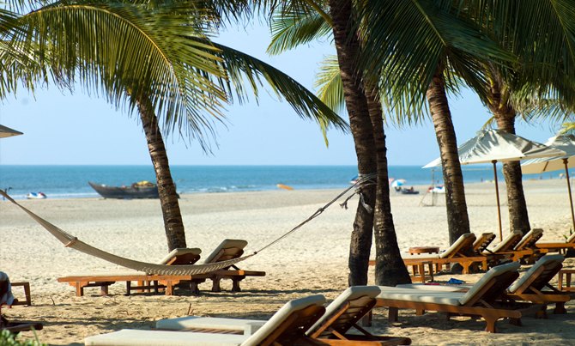**Meal Plan:** Breakfast

**Day 10: In Goa**

Day at leisure to explore on your own.

**Overnight at the hotel in Goa.**

**Meal Plan:** Breakfast

**Day 11: Depart Goa**

Transfer to Goa airport for flight to onward destination.

**Inclusions:**

* Accompanying cycling guide & mechanic
* Accompanying support vehicle throughout the trip
* Refreshments and drinking water during cycling throughout the trip
* First-Aid available

**Weather and Clothing**

* It will be hot and dry, with daytime temperatures up to 32 degrees centigrade.
* Sun cream is very strongly recommended.
* Head and eye protection are also essential.
* A light windproof/fleece might be needed in the evenings when visiting hill stations and for early morning descents.
* Ladies should cover their legs and shoulders when not cycling (a beach wrap is ideal for this; knee-length shorts are also useful).

**Cycles / Equipment**

* Essential gears need to be brought by the guest.
* Cycles to be provided.
* The cycle brands used are Cannondale, Trek, Scott, Giant & Btwin

**Key Information**

* There are refreshment breaks in between depending on the terrain.
* The above programme is feasible for a group of minimum 08 Pax and maximum 25 Pax.
* Please note two supporting vehicles (Tempo travelers) will be provided, one without seats for keeping the bikes and the other with seats for the group members.
* All group members may not be cycling at the same speed. Therefore, support vehicles will follow behind the last cyclist. Whenever anyone wants to stop cycling and rest, the support vehicles will provide the assistance.

**-X-**